How to create a curriculum PR

- While logged in to your GitHub account navigate to the file that needs editing and click the pencil icon in the top right corner
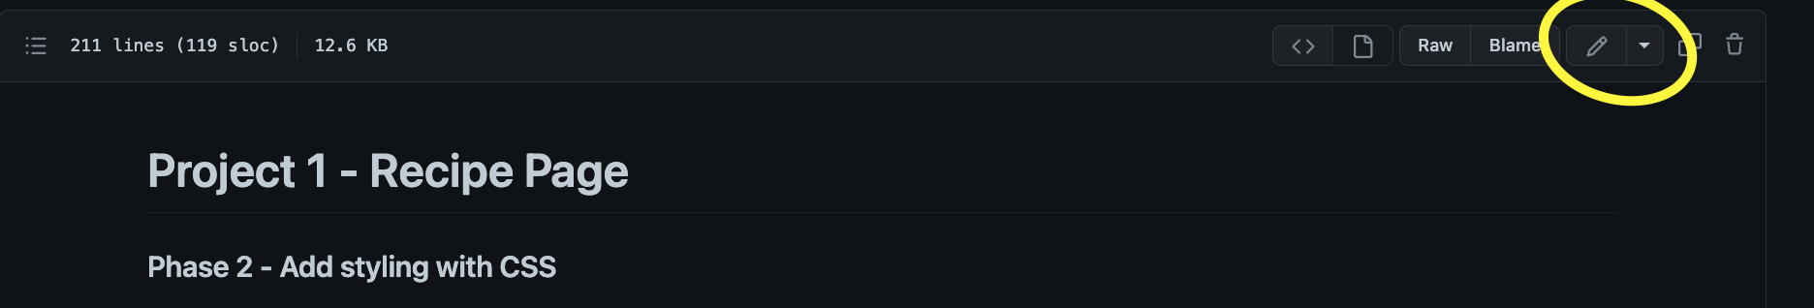
- This will change the view to the markdown view. You will be able to edit the code here. So write out where things need to be changed (Underlined is what I added)
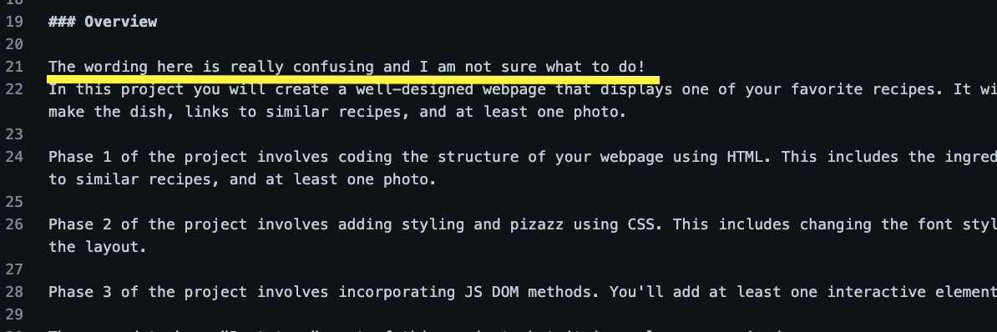
- Down at the bottom of the page create a new commit in a new branch with a message with any more detail you would like to add, press propose changes
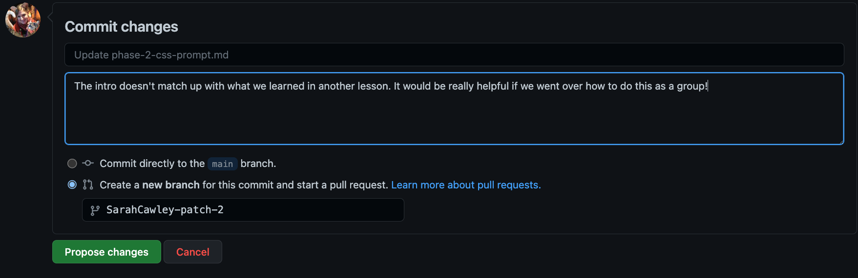
- Create a Pull Request (click the underlined button) **Don’t worry your changes won’t go live, and you can not mess up the curriculum!**
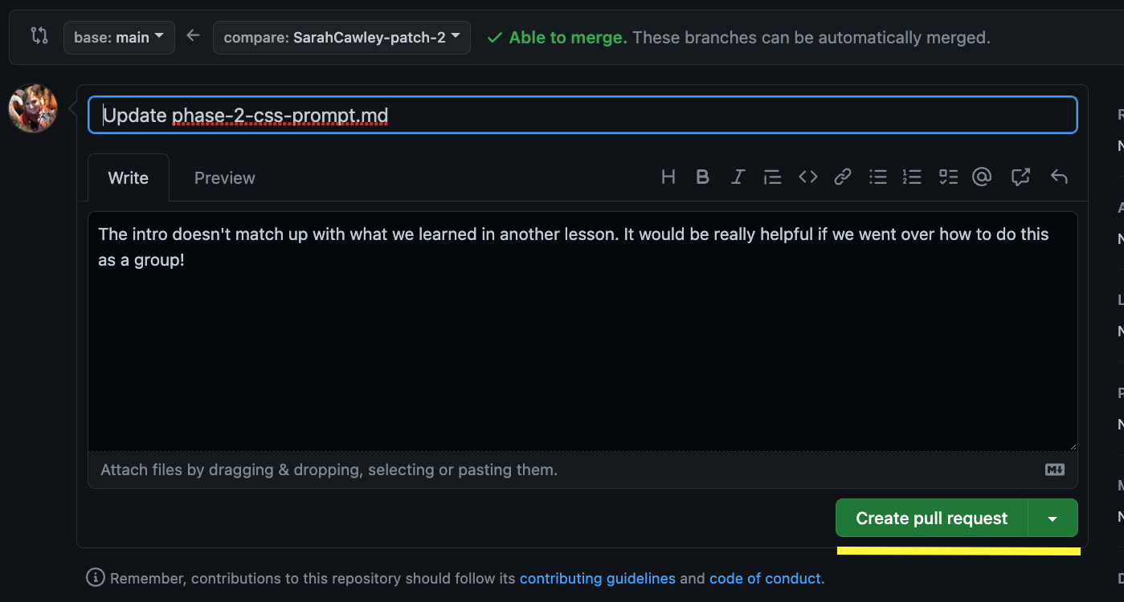
- The technical staff will get a notification there is a new PR and we will review it. This is what we will see. We will have the option of editing your changes so don’t worry if what you have done is not perfect, it is a great starting place!
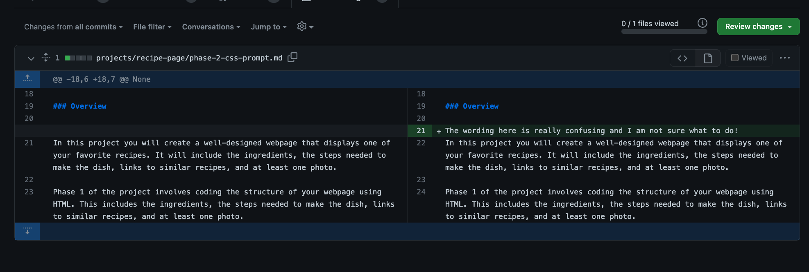
- That is it! You have now contributed to an open source project!!

Note: I know it can be really scary when you are new to Git and GitHub to edit other people’s work. Please try to remember that you can not damage anything! Any changes you make will have to be reviewed and approved by a staff member. Your contributions will only make the curriculum and the program stronger!

The example I made is for a basic PR. If there is a more technical issue you have found, and you have worked out a fix with your group or your mentor please feel free to update that entire section! You can also share links with us to your code or a doc where you have an explanation. Any information you can give us is extremely helpful.

